Assessment Schedule – 2012
Physics: Demonstrate understanding of aspects of electricity and magnetism (90937)
Assessment Criteria
Significant figures are not required and correct units are required only in the questions that specifically ask for them.
Question | Achievement |  |  |  | Merit |  |  |  | Excellence
ONE  (a) | Fibres are charged by rubbing.  OR  Charges are transferred between fibres and table. |  |  |  | Rubbing against the table causes transfer of negative charges / electrons transferred to the table/ from the duster
(b) | All fibres have the same charge.  OR  Like charges repel.
(c) | Diagram shows induced charges on the dust particle.  OR  Mentions dust particles are attracted because they have opposite charges. |  |  |  | Explains that charge separation takes place in the dust particle and the part of the dust particle near the fibre becomes oppositely charged. Since opposite charges attract, it is attracted to the fibre. |  |  |  | Explains that charge separation means attractive force from unlike charges is greater than repulsion from like charges
(d) | Either correct answer to (i) – electric discharge/ electrons transferring or (ii) – electrons transfer to the cleaner, is given  OR  the value of power is calculated in (iii). |  |  |  | EITHER correct answer to (i) The spark is the discharge of electrical energy / a current in air.  AND (ii) The negative charges / electrons from the door knob are transferred to his body, thereby neutralising the positive charges in his body.  OR  Correct process for (iii) |  |  |  | The negative charges / electrons from the door knob are transferred to his body, thereby neutralising the positive charges in his body.  AND  Power, P = VI =  = 9 000 × 2.5 × 10^{–7}  = 2.25 × 10^{–3} W  Energy, E = P × t  = 2.25 × 10^{–3} × 0.0015  = 3.4 × 10^{–6} J
NØ |  | N1 | N2 | A3 |  | A4 | M5 | M6 |  | E7 | E8
No evidence |  | 1a | 2a  OR  1m | 3a  OR  1a+1m |  | 4a | 2m | 3m |  | 1m+1e | 2e
Question | Achievement |  |  |  | Merit |  |  |  | Excellence
TWO  (a)(i)  (ii) | Parallel circuit.  OR  Bulbs receive full voltage / voltage not shared |  |  |  | Parallel circuit.  AND  Brightness is related to the voltage, and all bulbs have 12 V across them.
(b) | Calculates the total current correctly.  OR  Correctly calculates resistance of an individual bulb = 40 Ω |  |  |  | Total current = 0.30 × 5 = 1.5 A  Total resistance, 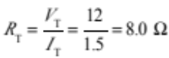 |  |  |  | `
(c)(i)  (ii) | Calculates the power output by each bulb correctly. (3.6 W)  OR  Mentions that the total power of the light will decrease.  OR  the other bulbs will be the same brightness |  |  |  | Correctly calculates Total power (18 W)  OR  Calculates the power output by each bulb correctly. (3.6 W)  AND 1 of  Mentions that the total power of the light will decrease.  OR  the other bulbs remain same brightness so total brightness is less  OR  Explains that the power of each bulb is the same because same current or voltage.  OR  Brightness decreases by 1/5 |  |  |  | Power output by each bulb,  P = VI  = 12 × 0.30 = 3.6 W  Total power output  = 3.6 × 5 = 18 W  AND  The total power of the light will decrease because 1 of  - The voltage across and current through the other bulbs will be unaffected.  - The power of the other four bulbs will remain the same.  OR  - Power will decrease by 1/5 (implies same power of other bulbs remains the same)
(d) | Recognises that brightness decreases.  OR  In series circuit so no bulbs will light as one is blown |  |  |  | - The brightness is less.  PLUS one of the following reasons:  - The voltage is shared because bulbs are in series.  - So less current through each bulb because bulbs are in series.  OR  In series no bulbs will light as one is blown so current/electrons will not flow |  |  |  | Brightness is less because power is less as both voltage and current are reduced for the bulbs in a series circuit.
NØ |  | N1 | N2 | A3 |  | A4 | M5 | M6 |  | E7 | E8
No evidence |  | 1a | 2a  OR  1m | 3a  OR  1a+1m |  | 4a | 2m | 3m |  | 1m+1e | 2e

Question |  | Achievement |  |  | Merit |  |  |  | Excellence
THREE  (a)(i)  (ii) |  | Either (i) or (ii) is given. |  |  | 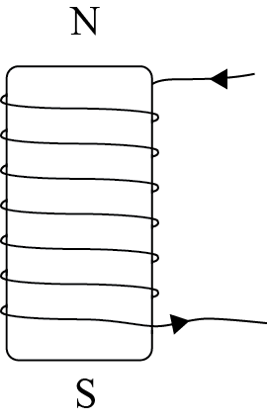  AND  Explained the right hand grip rule or any other valid rule – must indicate how current direction links to magnetic poles.
(b) |  | Describes individual aspects of the operation.  For example:  - The ball is attracted to the solenoid.  OR  - The solenoid becomes magnetised. |  |  | Three of the five points given in Excellence column |  |  |  | Three correctly linked points from  - Current flows through the circuit, causing the solenoid to become magnetised.  - The solenoid attracts the ball, lifting it up.  - This breaks the circuit stopping the current flow.  - The solenoid is no longer magnetic, and the ball falls down.  AND  - This remakes the circuit or causes the cycle to repeat.
(c) |  | States that aluminium is not magnetic.  OR  Ball is not attracted to the solenoid |  |  | Explains that aluminium is not magnetic, so it will not be attracted by the solenoid,
(d) |  | The strength of the magnetic field increases. |  |  | The strength of the magnetic field doubles  OR  The magnetic field strength increases because each extra turn adds a certain amount of field strength. |  |  |  | The magnetic field strength doubles because each extra turn adds a certain amount of field strength. So doubling the turns doubles the field strength.
NØ | N1 |  | N2 | A3 |  | A4 | M5 | M6 |  | E7 | E8
No evidence | 1a |  | 2a  OR  1m | 3a  OR  1a+1m |  | 4a | 2m | 3m |  | 1m+1e | 2e

Question | Achievement |  |  |  | Merit |  |  |  | Excellence
FOUR  (a) | EITHER the correct shape OR the correct direction is given. |  |  |  | BOTH the correct shape and the correct direction are given.  
(b) | The point X is in the correct location.  OR  Total field strength is zero because the fields cancel each other out. |  |  |  | Both fields at X are equal in size OR opposite in direction. So they cancel out each other.  
(c)(i)  (ii) | EITHER (i) is correct.  OR  Mentions that the iron filings fall off the soft iron piece. |  |  |  | 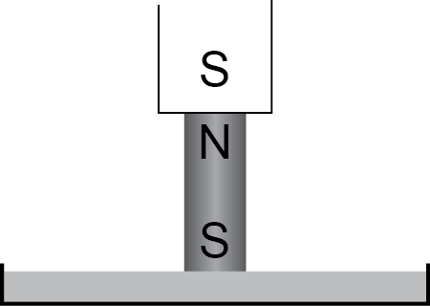  The soft iron piece loses its magnetism, and (most) iron filings fall off it. |  |  |  | The Soft iron forms a temporary magnet when in contact with the permanent magnet. When the external magnet is removed the soft iron demagnetises and the iron filings fall off.
(d)(i)  (ii) | EITHER the shape or the direction correct in (i).  OR  The current is calculated correctly.  OR  Correct unit (T or Tesla) for Magnetic Field Strength. |  |  |  | EITHER (i) is correct – shape and direction.  OR  Correct working for (ii). |  |  |  | 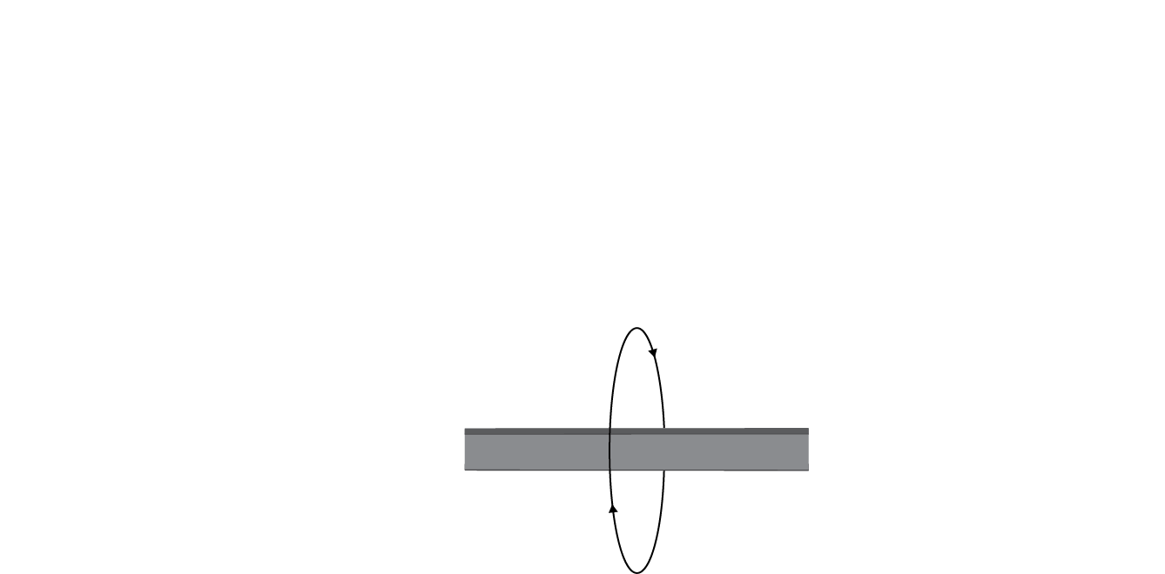  AND  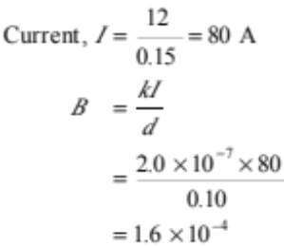
NØ |  | N1 | N2 | A3 |  | A4 | M5 | M6 |  | E7 | E8
No evidence |  | 1a | 2a  OR  1m | 3a  OR  1a+1m |  | 4a | 2m | 3m |  | 1m+1e | 2e

Judgement Statement

 | Not Achieved | Achievement | Achievement  with Merit | Achievement  with Excellence
Score range | 0 – 10 | 11 – 19 | 20 – 25 | 26 – 32

